ITA0601 – MACHINE LEARNING
LAB EXPERIMENTS
EXP-10: Expectation & Maximization Algorithm
Dataset 1 – Student Marks
Student | Marks
1 | 35
2 | 40
3 | 42
4 | 45
5 | 78
6 | 80
7 | 82
8 | 85
9 | 88
10 | 90

Python Code:
import numpy as np
import matplotlib.pyplot as plt
from sklearn.mixture import GaussianMixture
X = np.array([35, 40, 42, 45, 78, 80, 82, 85, 88, 90]).reshape(-1, 1)
model = GaussianMixture(n_components=2, random_state=42)
model.fit(X)
clusters = model.predict(X)
print("Student Marks:")
print(X.flatten())
print("\nCluster assigned to each student:")
print(clusters)
print("\nCluster Means:")
print(model.means_.flatten())
print("\nCluster Weights:")
print(model.weights_)
plt.scatter(X, np.zeros(len(X)), c=clusters, s=100)
plt.xlabel("Marks")
plt.title("EM Algorithm - Student Marks")
plt.show()
Output:
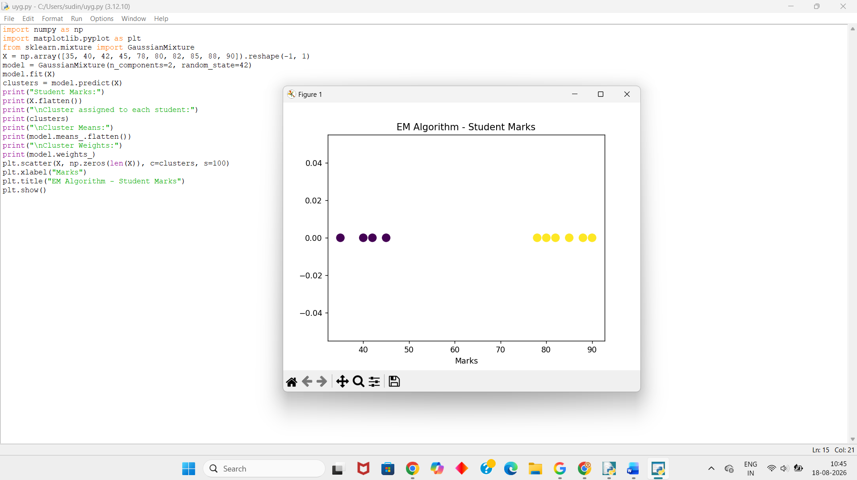
Dataset 2 – Customer Spending
Customer | Spending (₹)
1 | 1000
2 | 1200
3 | 1300
4 | 1500
5 | 5000
6 | 5200
7 | 5500
8 | 5800
9 | 6000
10 | 6200
Python Code:
import numpy as np
import matplotlib.pyplot as plt
from sklearn.mixture import GaussianMixture
X = np.array([1000, 1200, 1300, 1500, 5000, 5200, 5500, 5800, 6000, 6200]).reshape(-1, 1)
model = GaussianMixture(n_components=2, random_state=42)
model.fit(X)
clusters = model.predict(X)
print("Customer Spending:")
print(X.flatten())
print("\nCluster assigned to each customer:")
print(clusters)
print("\nCluster Means:")
print(model.means_.flatten())
print("\nCluster Weights:")
print(model.weights_)
plt.scatter(X, np.zeros(len(X)), c=clusters, s=100)
plt.xlabel("Customer Spending")
plt.title("EM Algorithm - Customer Spending")
plt.show()
Output:
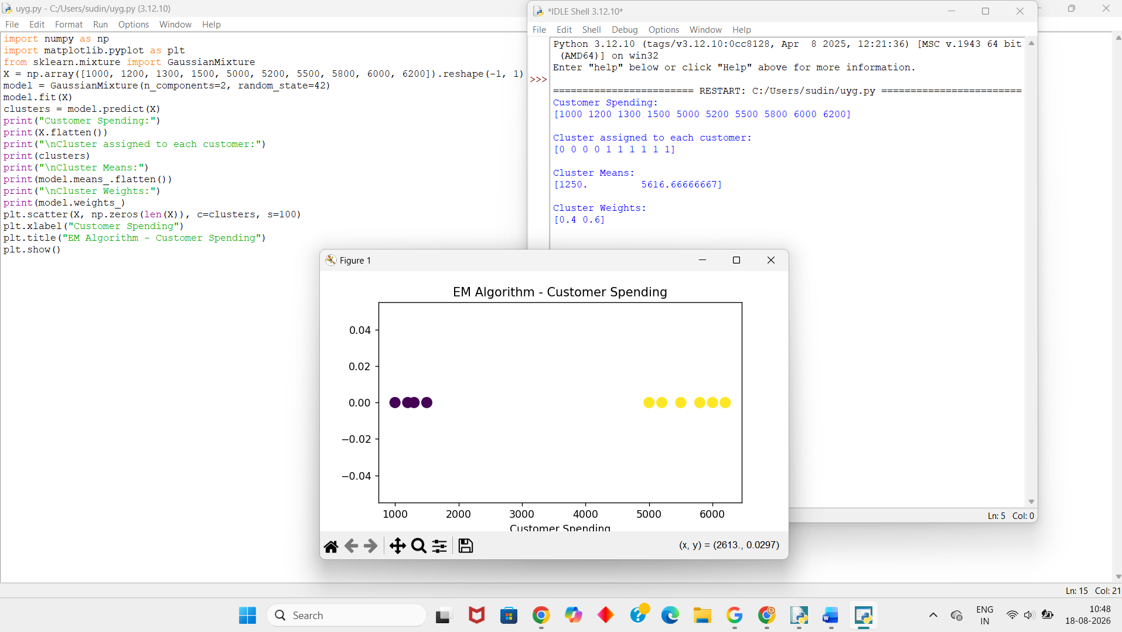
Dataset 3 – Employee Salary
Employee | Salary (₹)
1 | 18000
2 | 20000
3 | 22000
4 | 24000
5 | 55000
6 | 58000
7 | 60000
8 | 63000
9 | 65000
10 | 68000
Python Code:
import numpy as np
import matplotlib.pyplot as plt
from sklearn.mixture import GaussianMixture
X = np.array([
18000, 20000, 22000, 24000,
55000, 58000, 60000, 63000, 65000, 68000
]).reshape(-1, 1)
model = GaussianMixture(n_components=2, random_state=42)
model.fit(X)
clusters = model.predict(X)
print("Employee Salaries:")
print(X.flatten())
print("\nCluster assigned to each employee:")
print(clusters)
print("\nCluster Means:")
print(model.means_.flatten())
print("\nCluster Weights:")
print(model.weights_)
plt.scatter(X, np.zeros(len(X)), c=clusters, s=100)
plt.xlabel("Salary")
plt.title("EM Algorithm - Employee Salary")
plt.show()
Output:
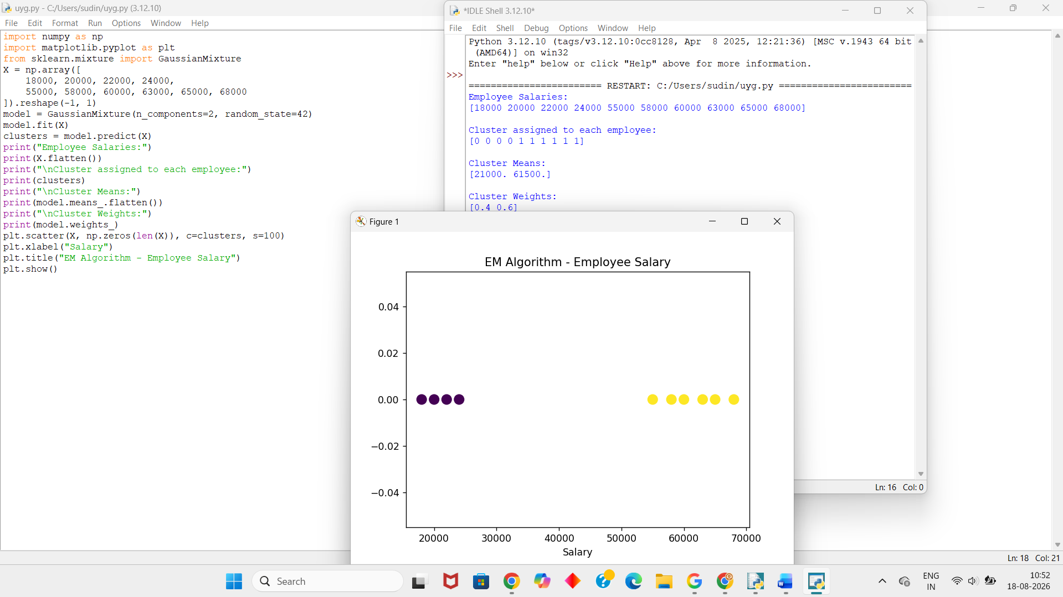
Dataset 4 – House Prices
House | Price (Lakhs)
1 | 25
2 | 28
3 | 30
4 | 32
5 | 75
6 | 80
7 | 85
8 | 90
9 | 95
10 | 100
Python Code:
import numpy as np
import matplotlib.pyplot as plt
from sklearn.mixture import GaussianMixture
X = np.array([
25, 28, 30, 32,
75, 80, 85, 90, 95, 100
]).reshape(-1, 1)
model = GaussianMixture(n_components=2, random_state=42)
model.fit(X)
clusters = model.predict(X)
print("House Prices:")
print(X.flatten())
print("\nCluster assigned to each house:")
print(clusters)
print("\nCluster Means:")
print(model.means_.flatten())
print("\nCluster Weights:")
print(model.weights_)
plt.scatter(X, np.zeros(len(X)), c=clusters, s=100)
plt.xlabel("House Price (Lakhs)")
plt.title("EM Algorithm - House Prices")
plt.show()
Output:
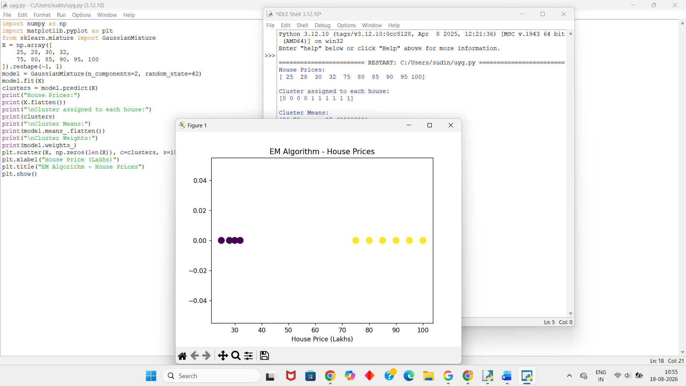
Dataset 5 – Temperature
Day | Temperature (°C)
1 | 18
2 | 20
3 | 21
4 | 23
5 | 30
6 | 32
7 | 33
8 | 35
9 | 36
10 | 38
Python Code:
import numpy as np
import matplotlib.pyplot as plt
from sklearn.mixture import GaussianMixture
X = np.array([
18, 20, 21, 23,
30, 32, 33, 35, 36, 38
]).reshape(-1, 1)
model = GaussianMixture(n_components=2, random_state=42)
model.fit(X)
clusters = model.predict(X)
print("Temperature:")
print(X.flatten())
print("\nCluster assigned to each day:")
print(clusters)
print("\nCluster Means:")
print(model.means_.flatten())
print("\nCluster Weights:")
print(model.weights_)
plt.scatter(X, np.zeros(len(X)), c=clusters, s=100)
plt.xlabel("Temperature (°C)")
plt.title("EM Algorithm - Temperature")
plt.show()
Output:
